Step by Step Installation MySQL on Microsoft Windows Using MySQL Installer
Installer Name | mysql-installer-community-5.6.19.0.msi
Installer Package Types | Web
Installer Editions | Community edition

- Go to the following link to download MySQL Installer:
http://dev.mysql.com/downloads/installer/
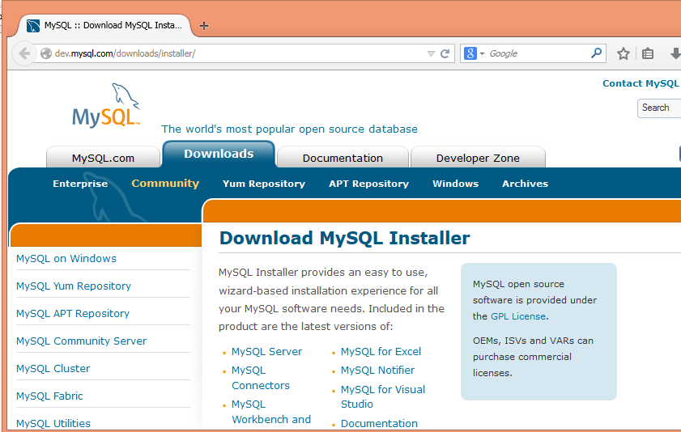
- MySQL is available for Microsoft Windows, for both 32-bit and 64-bit versions. Please choose your windows version and download it.
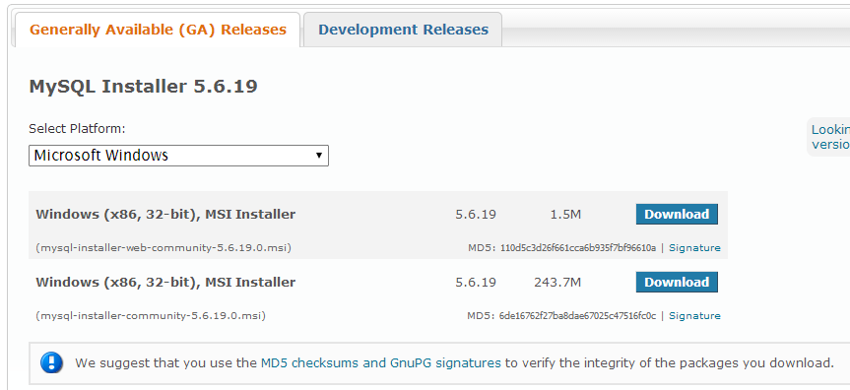
- After the installer has been downloaded, double click this installer to install.

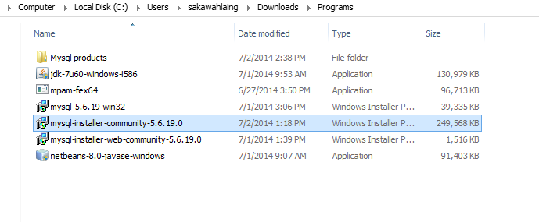
- The following screen will be displayed:
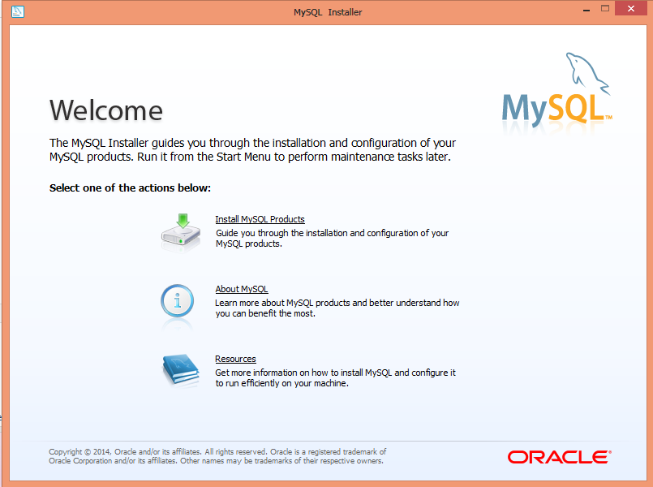
- Click Install MySQL Products. The following screen will be displayed:
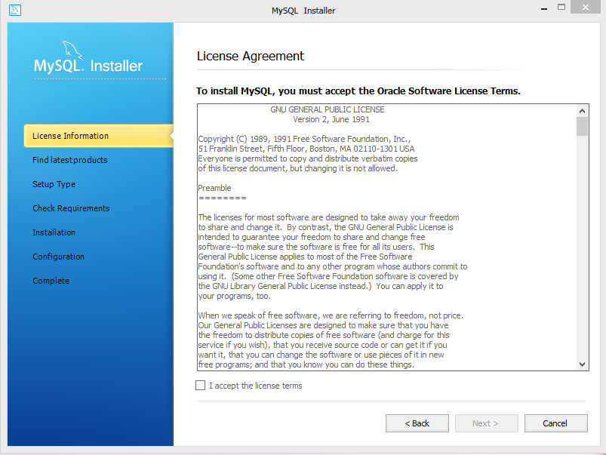
Check this check box and click Next Button

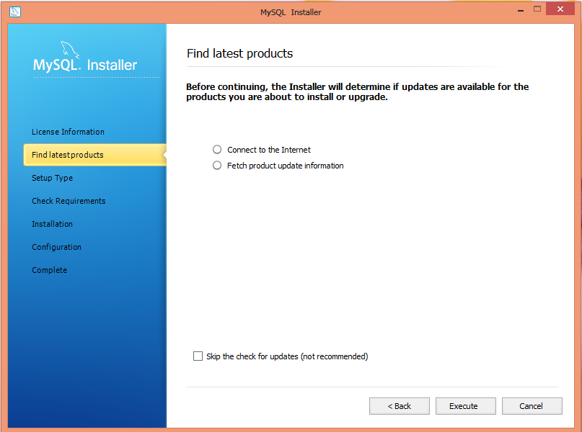
Click execute button.

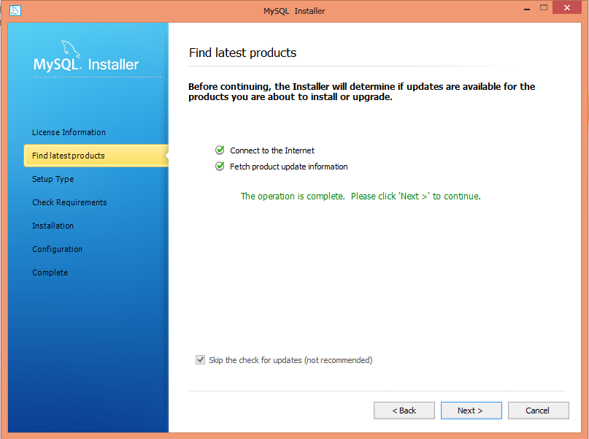
- When the search is complete , you will be taken to the Choose Setup Type page:
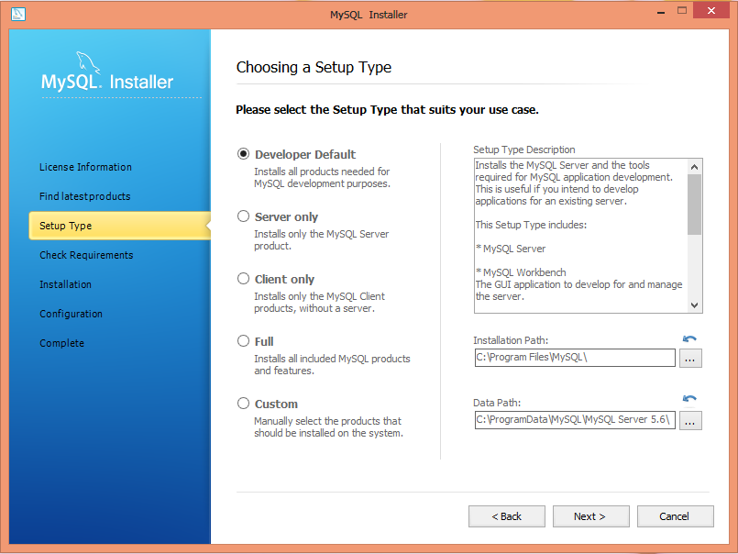
- After you select a setup type, the MySQL Installer will check your system for the necessary external requirements and download then install missing components onto your system.

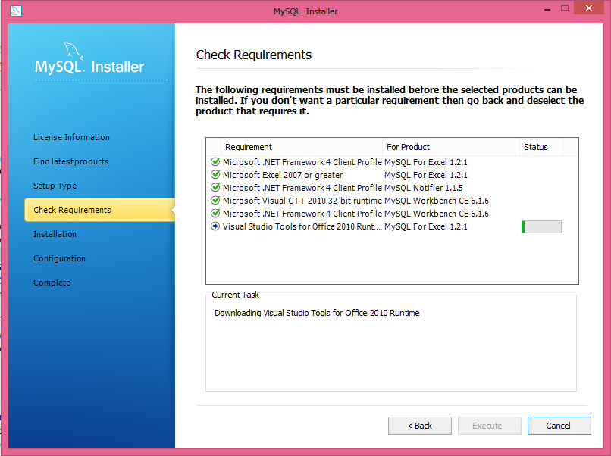
- The next window lists the MySQL products that are scheduled to be installed:
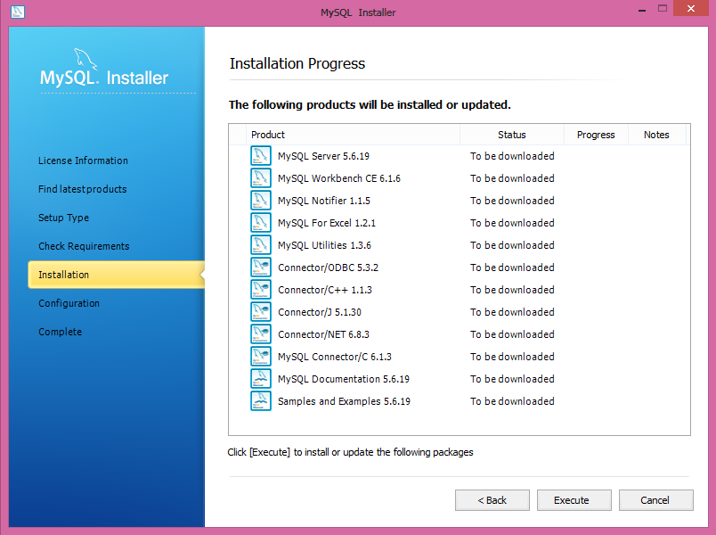
Click execute button.

- As components are installed, you'll see their status change from "to be downloaded" to "install success."
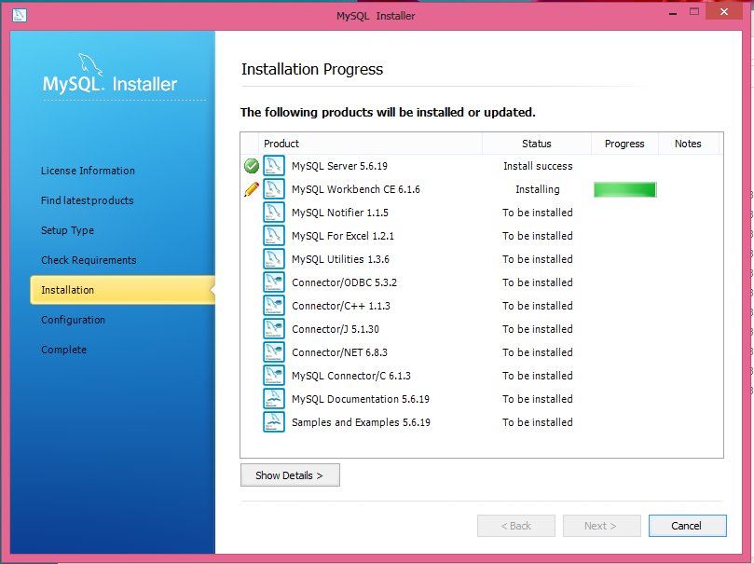
- After all components are installed, Configuration Overview window will be displayed.
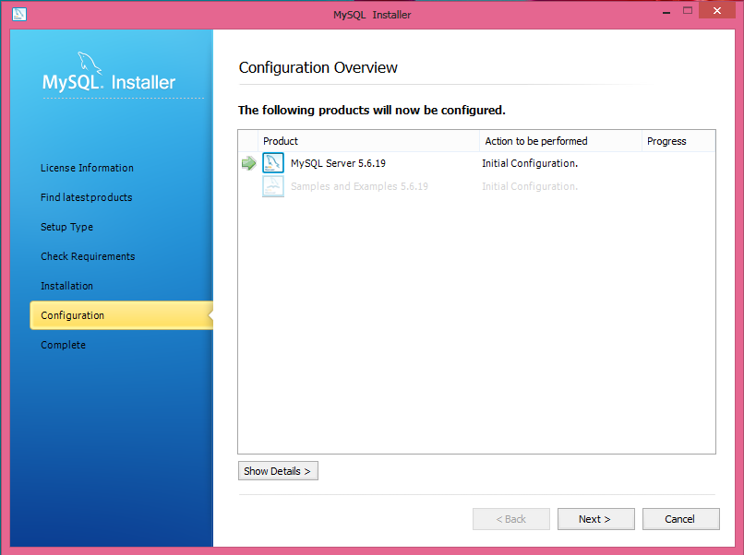
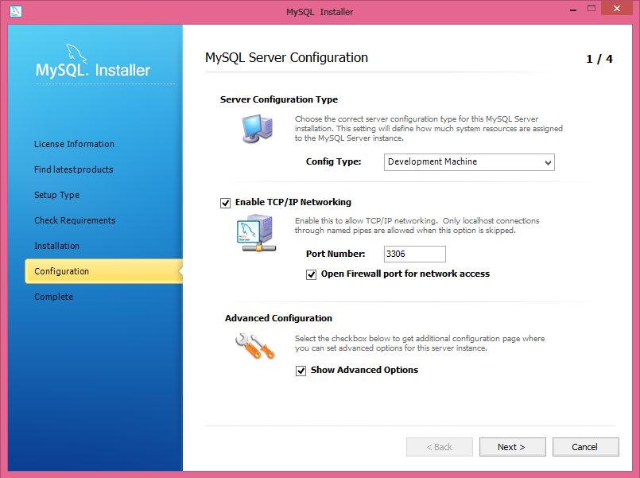
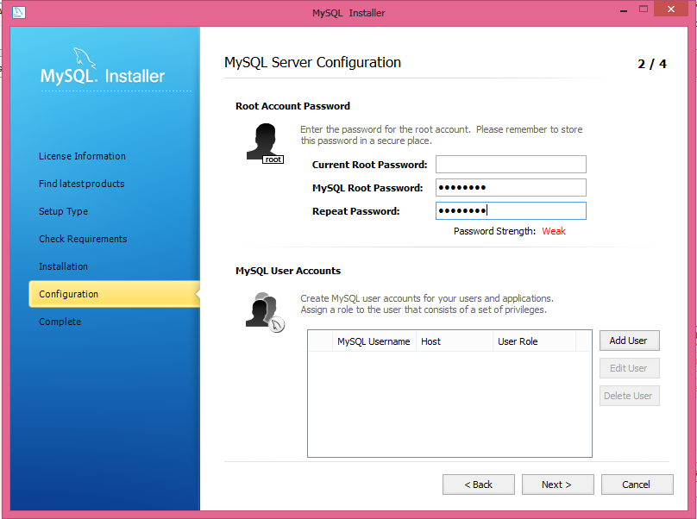
Defining a root password is required.
Click Add User to create user role.
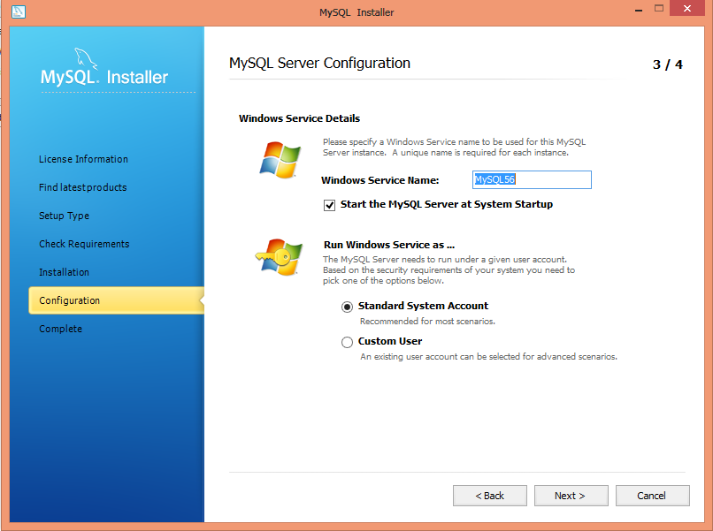
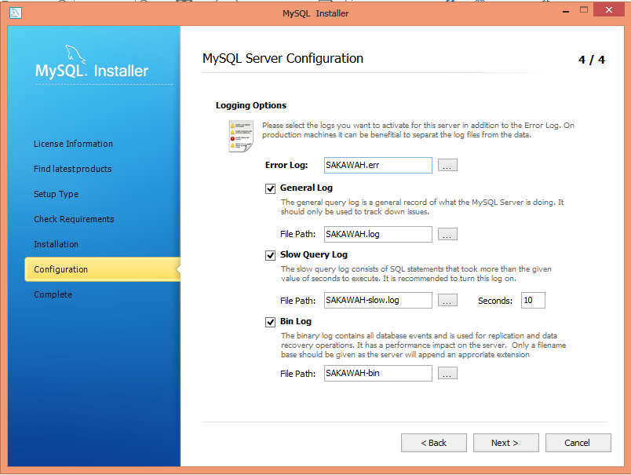
- After the MySQL Installer configuration process is completed, this screen will be displayed.
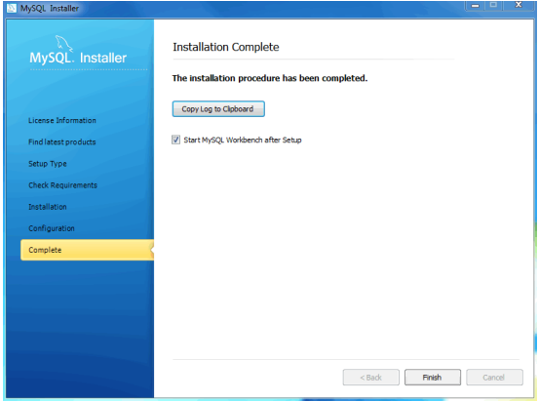
- After Clicking Finish button, MySQL Workbench will be opened.
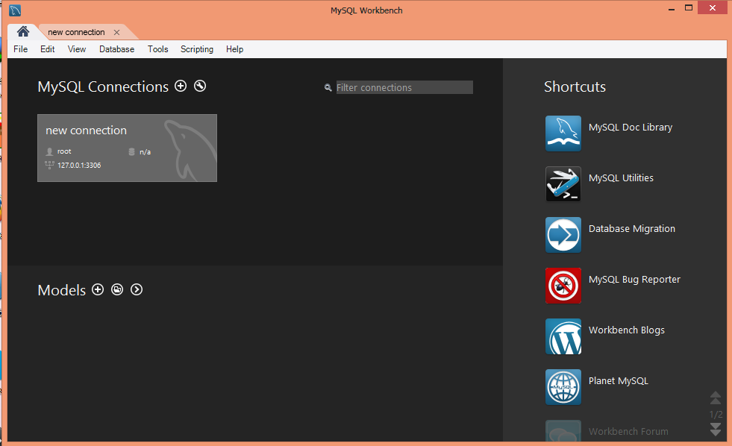
- You can now open MySQL Installer from the Microsoft Windows Start menu which will load the MySQL Installer Maintenance Screen. This is used to add, update, and remove features.
